#### **1. Business Overview and Processes**

Software Organization:

1. IT Team: 10 Persons
   1. Independent team focused on back-end capabilities
   2. Development of networking, servers, and data basing
   3. Maintains hospital back-end functionality.
2. Software Development Team: 10 Persons
   1. Independent team focused on front-end capabilities
   2. Development of hospital’s website and mobile applications
   3. Integrates with IT team’s back-end systems
   4. Focus on new software developments and interacting with stakeholders.

The Drexel County General Hospital (DCGH) located in Philadelphia has been updating their systems to support the increasing number of patients after recent population growth in the surrounding area. In the past, the hospital relied on physical record keeping, but this method has become too cumbersome and time consuming for the staff to quickly process information for their patients. The hospital has been migrating physical information such as appointments, patient info, and prescriptions to a digital system. The development efforts include creating a back-end system to store and input old records as well as creating new front-end software (website/app) for the staff and patients.

The existing work is composed of two separate teams, the IT team responsible for the back-end and Software Development team responsible for the front-end. Each team works separately on their capabilities with integration events to work through interface issues. Of the two teams, the IT group has a longer legacy at the hospital as they started overhauling the existing paper records to a digital format. Because of this, they have a split responsibility between maintaining the existing servers, network and databases as well as creating interfaces for the front-end team’s applications. The Software Development team was recently formed to create new applications for both the staff and patients.

As shown in the Business Process graphic, the DCGH would like to update their processes to a digital format. The teams were tasked to analyse their existing documentation practices and adopt them to mobile apps or websites. Given the in house effort, limited requirements were given to the teams for them to work with. Instead, they were given an open ended request by hospital management to overhaul their paper processes.

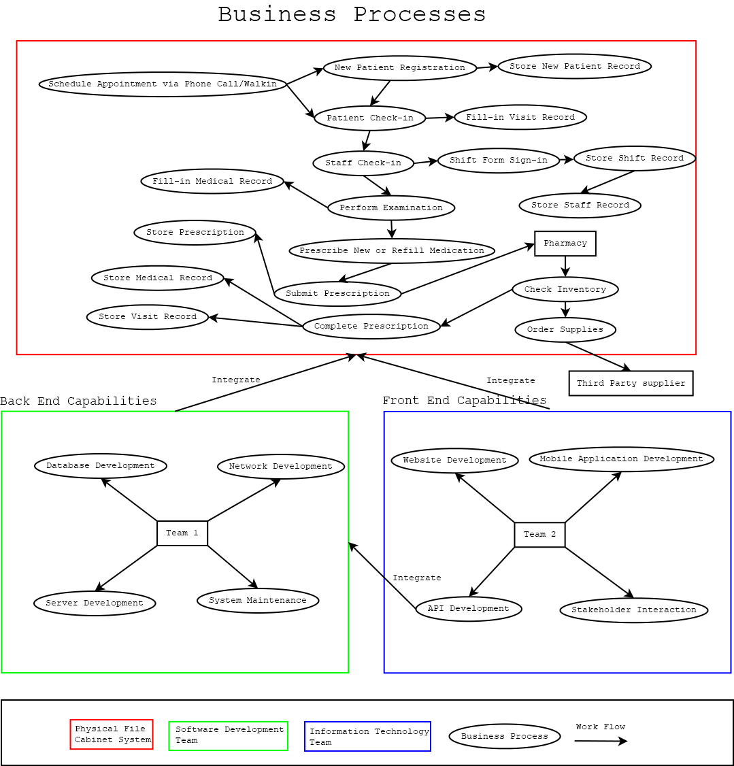

Figure 1: The current business process and new system to be integrated. The workflow in red borderline is the original physical file cabinet system, the green and blue frame are two parts of the new system. The front-end capabilities are the software development team’s responsibility, the back-end capabilities are the information technology team’s goal.

#### **2. Problem Analysis**

The core of the DCGH software development issues come from managing two separate teams. The IT and software team need to continuously integrate their capabilities as they have capability gates on proceeding further. At a high level, they struggle from communication, integration, and lack of defined requirements.

Since, the front-end team is never given a clear set of requirements from the hospital’s stakeholders, they often face scope creep as they make assumptions for new websites and applications. It’s routine that the first time the stakeholders see software it’s at the end after months of development. Unfortunately, the lack of requirements and assumptions compound to stakeholders being unsatisfied. In addition, the scope creep accumulated from the project causes late deliveries.

The IT team is split between two responsibilities of maintaining existing back-end infrastructure as well as providing new capabilities to the software team. Their current process is not defined to support this workload. Instead of distributing work, they resort to working issues as an all hands strategie. This is inherited from when they first began developing the back-end system and has not been revised. The legacy processes cause delays to all stakeholders as the team exclusively works either maintaining or new development tasks at any time.

Together, the teams also struggle communicating their progress and task priority. For example, the software team will develop a mobile app that needs to request information from the IT teams server regarding patient information. However, until IT creates this interface, the software team is forced to work on other capabilities or delay the deliverable.

* Software development team does not have a clear set of requirements for hospital application needs or capabilities
  + What type of database system is needed long term.
  + What the website or mobile app needs to look like.
  + What information needs to be converted to digital format.
* Software development team is split between IT and Website/App development creating integration issues.
  + The IT team designs and develops back-end databases and networking.
  + Software team integrates front-end applications to the IT team’s systems.
  + Integration issues come from communication and lack of defined interfaces.
* The team is continually trying to add in cyber security at the end of integration instead of during development.
  + Cyber security is not fully implemented in networking/app communication.
* Each team constantly waiting on each other causing delays for deliverables resulting in wasted time and shifted critical paths.
  + The lack of systems engineering causes delays in integration events.
  + Capabilities are late due to teams developing components without priority.
* IT team has difficulty shifting work from developing new systems and maintaining existing infrastructure.
  + The IT team typically takes tasks as all hands instead of distributing workload.
  + The rapid priority shift from maintaining existing systems and creating new capabilities for software development team causes delays for everyone.